**Laboratory 4:**

Speed of Sound and Light

**Name:** Omar Ozgur

**Date:** Feb 11, 2016

**Lab:** Section 7, Thursday 8:00am

**TA:** Nicholas Rombes

**Lab Partner:** Uday Alla

**1. Introduction**

The purpose of this laboratory experiment was to calculate the speed of light and sound. In the first section of the experiment, a microphone was moved away from a loudspeaker along a linear track in order to view the waveform at various distances. The analysis of this data allowed for the speed of sound to be calculated. In the next part of the experiment, a large reflector was moved toward the microphone, and the waveform based on the output of the loudspeaker was recorded once again. A potentiometer allowed for the movement distance to be calculated, and analysis of the peak voltages from the microphone allowed for the speed of sound to be calculated once again.

In another section of the experiment, two mirrors were used to reflect light from a laser pulser into a laser diode. The starting time of each pulse, as well as the time that the light hit the diode, was shown on an oscilloscope. By placing one mirror close to the diode, and one further away, the distance between the mirrors could be used along with the oscilloscope data to determine an experimental value for the speed of light.

**2. Experimental Results**

2.1 Traveling Sound Waves

In the first section of the experiment, a small microphone was powered by a 12 V DC power supply, and a function generator was used to supply a 3.0 ± 0.5 kHz sine wave to a loudspeaker. The output of the function generator was also connected to the channel 1 input of an oscilloscope, and an AC BNC connection from the microphone was connected to channel 2. By moving the microphone along a linear track, the phase shift of the incoming signal was shown to linearly increase with the distance from the speaker. The experimental setup is shown in figure 1.

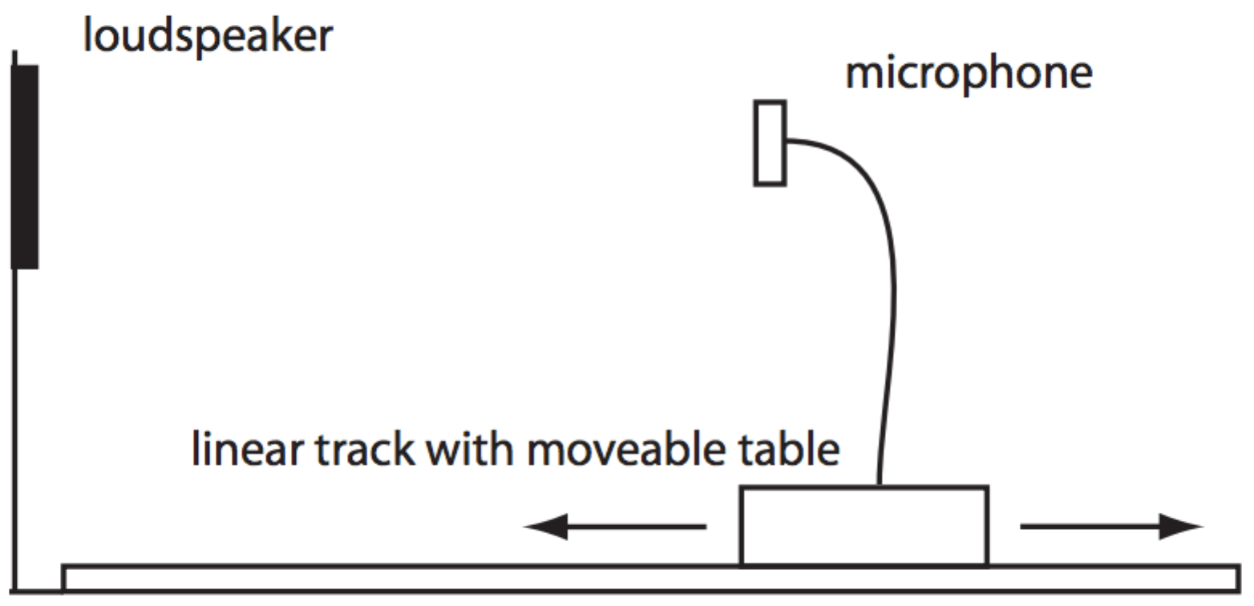

Figure : Traveling Sound Wave Setup: This image shows the experimental setup that was used to analyze traveling sound waves. By varying the voltage sinusoidally to the loudspeaker, a sinusoidal voltage is also detected by the microphone. The phase shift was shown to change linearly with distance as the microphone was moved toward or away from the loudspeaker on a linear track. (Source: UCLA Physics 4BL Lab Manual, Winter 2016)

In order to determine the wavelength of the detected sound waves, the microphone was initially moved to a position that caused the two wave patterns to be completely in phase. The microphone was then moved away from the loudspeaker, and the distance of the microphone from the speaker was recorded when the phase changed by π and 2π.

These steps were repeated 4 more times for the frequencies 6.0 ± 0.5 kHz, 9.0 ± 0.5 kHz, 12.0 ± 0.5 kHz, and 15.0 ± 0.5 kHz. The speed of sound *v* could be determined based on the recorded frequencies *f* and wavelengths *λ* for each set of data due to the relation . Based on the recorded data, the dispersion relation was created by plotting the wavevectors against corresponding angular frequencies, as shown in figure 2.

Figure : Dispersion Relation for Traveling Sound Waves: This graph shows the relation between the calculated wavevectors and angular frequencies for each of the 5 tested frequencies. The fact that these points lie close to a linear trend line shows that the speed of sound does not vary with frequency. By performing linear regression analysis with Microsoft Excel, the slope of the trend line was found to be 347 ± 2 m/s, which is the experimental value for the speed of sound.

By using Microsoft Excel to perform regression analysis on the data, the slope of the linear trendline could be determined, which gave the calculated value for the speed of sound. This value was found to be 347 ± 2 m/s.

2.2 Standing Sound Waves

In the second part of the experiment, the goal was to determine the speed of sound based on standing sound waves. In order to do this, a metallic reflector was placed near a loudspeaker so that sound waves would be reflected back toward the source. A microphone was placed behind the speaker so that it could record the interference pattern between the incident and reflected sound waves. The experimental setup is shown in figure 3.

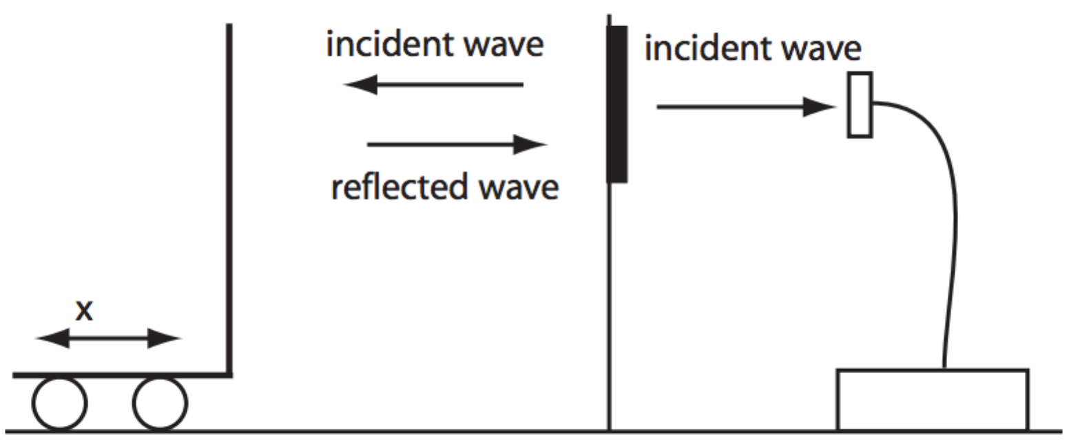

Figure : Standing Sound Wave Setup: This image shows the experimental setup that was used to analyze standing sound waves. A metallic reflector was used to reflect sound waves that were generated by a loudspeaker. A microphone was placed behind the speaker so that it could measure the amplitude of the generated standing waves based on the incident and reflected waves. Analysis of the output voltage from the microphone could be used to determine the wavelength of the sound waves. (Source: UCLA Physics 4BL Lab Manual, Winter 2016)

The maximal microphone voltage output occurred when the microphone was placed at an antinode of the standing wave, and the minimal output occurred when the microphone was placed at a node. By moving the reflector toward and away from the loudspeaker, the standing wave pattern was altered. By analyzing the voltage output of the microphone based on the distance that the reflector was moved, the nodes and antinodes in the standing wave could be determined, which allowed for the wavelength to be calculated.

In order to determine the distance that the reflector was moved, an attached potentiometer was supplied with a 2 V DC power supply, and the output voltage was monitored with a multimeter. In order to calibrate the reflector’s position, the reflector was moved in increments of 5.0 ± 0.5 cm, and the voltage at each position was recorded. These distances and voltages were plotted on a graph, as shown in figure 4.

Figure : Potentiometer Calibration: The data points in this graph show the relationship between the distance that the reflector was moved, and the output voltage from the attached potentiometer. The linear trend line shows that the output voltage of the potentiometer varied linearly with the movement of the reflector. By performing linear regression analysis in Microsoft Excel, the slope of the trend line was found to be 1.90 ± 0.03 m/V, which can be used to convert the potentiometer’s output voltage to distance.

In order to calculate the wavelength of the standing sound waves, the output voltage of the potentiometer was recorded through channel 0 of a myDAQ system, and the output voltage of the microphone was recorded through channel 1. Afterwards, a signal frequency of 5000 ± 10 Hz was used as input to the loudspeaker, and displayed on an oscilloscope. The uncertainty in this frequency value was determined by adjusting the time cursors on the oscilloscope to see how accurately features of the wave could be marked. In the provided “4BL” application, data from channel 0 of the myDAQ system was plotted against the data from channel 1 at a sampling rate of 10 points/sec. After converting the recorded potentiometer voltages to distances using the calculated potentiometer calibration constant, the data was plotted against the recorded microphone voltages. This data is shown in figure 5.

Figure : Microphone Output Voltage Based on Reflector Position: The data points in this graph show the microphone’s output voltage based on the distance that the reflector was moved. The distances values were found by multiplying the recorded potentiometer voltages by the calculated calibration constant. Since the output voltage of the microphone was greatest at the locations of antinodes in the standing waves, the maximum voltage values occurred when the reflector was moved half a wavelength.

Since the maximum output voltages of the microphone occurred at the locations of antinodes, and the minimum voltages occurred at the locations of nodes, the distance between successive maxima or minima in figure 5 represent movement of the reflector by half a wavelength. By doubling the distances between these maxima or minima, the full wavelength and speed of sound could be calculated at multiple points. 13 calculations of the wavelength and speed of sound based on data in figure 5 are shown in table 1. The uncertainties in the calculated values were found through the propagation of error formula in equation 3.

|  |  |
| --- | --- |
| **Wavelength (m)** | **Speed of sound (m/s)** |
| 0.071 ± 0.001 | 359 ± 5 |
| 0.062 ± 0.001 | 310 ± 5 |
| 0.084 ± 0.001 | 420 ± 5 |
| 0.076 ± 0.001 | 377 ± 5 |
| 0.078 ± 0.001 | 390 ± 5 |
| 0.077 ± 0.001 | 384 ± 5 |
| 0.074 ± 0.001 | 371 ± 5 |
| 0.083 ± 0.001 | 414 ± 5 |
| 0.084 ± 0.001 | 420 ± 5 |
| 0.080 ± 0.001 | 402 ± 5 |
| 0.076 ± 0.001 | 377 ± 5 |
| 0.072 ± 0.001 | 359 ± 5 |
| 0.083 ± 0.001 | 414 ± 5 |

Table : This table shows the calculated values for the wavelength of standing waves based on the data in figure 5, as well as calculations of the speed of sound. The uncertainties in these values were found based on the propagation of error formula in equation 3.

2.3 Speed of Light by Time of Flight

In the last part of the experiment, the goal was to measure the speed of light. In order to do so, power was supplied to a laser pulser, and the light was reflected off of a mirror, into a photodiode detector. A cable was used to connect the laser pulser to channel 2 of an oscilloscope, and another cable was used to connect the photodiode detector to channel 1 of the same oscilloscope. The experimental setup is shown in figure 6.

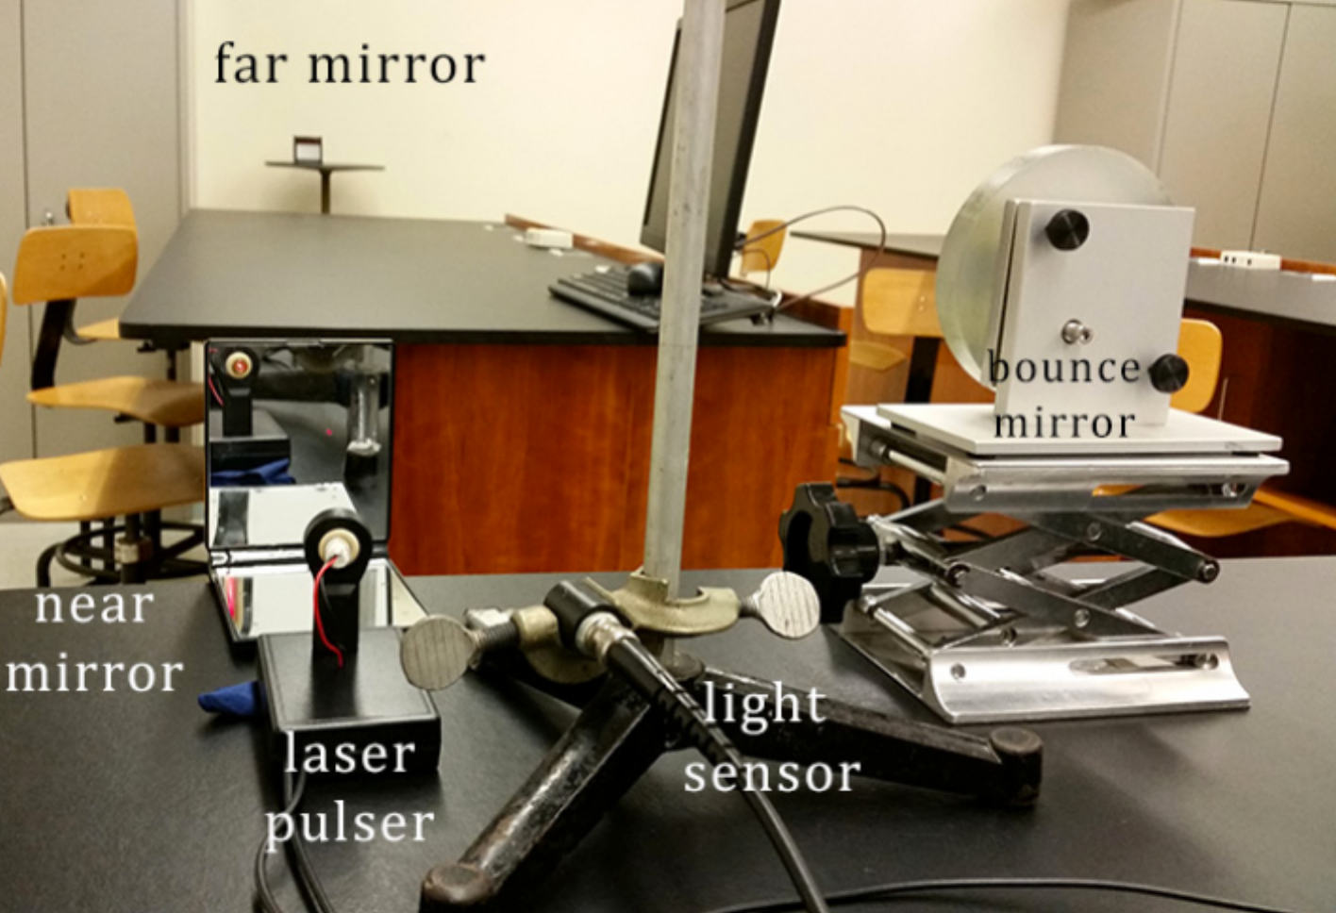

Figure : Experimental Setup for Calculating Speed of Light: This image shows the experimental setup that was used to calculate the speed of light. Light from a laser pulser was reflected into a photodetector diode by using mirrors that were at two different distances. An oscilloscope was used to monitor the change in the detection time of light at the diode, and this information was used to calculate the speed of light.

When the scope time base of the oscilloscope was set to 50 ms, square wave trigger pulses from channel 2 were clearly displayed. By adjusting the trigger level settings, the pulse was made to be stable in the center of the display.

After adjusting the trigger level, the time base was set to 25 ns. The laser pulser was used to reflect light between a far mirror and a close bounce mirror two times before the light hit the photodetector diode. The distance between the mirrors was measured to be 4.220 ± 0.005 m. Since the light traveled this distance 6 times, the total light path was found to be 25.32 ± 0.03 m. On the oscilloscope, the second time cursor was used to mark the detection time from the far mirror. Afterwards, the light was reflected off of a mirror that was close by, and the first time cursor was used to mark the new detection time. The change in detection time Δt was automatically calculated to be 87 ± 5 ns. The error in this measurement was estimated due to the fact that the detection time could only be determined to be within a range of 5 ns from the marked time values. If less than 128 average values were taken, it became more difficult to determine the detection time. If only 4 average values were taken, the uncertainty rose to about 10 ns.

After performing the experiment with a time base of 25 ns, the experiment was repeated with a time base of 10 ns. After repeating the procedure, the change in detection time Δt was found to be 85 ± 2 ns. The uncertainty was based on the smallest distance that the time cursors could be moved without noticeably miscalculating the detection time. Once again, if less than 128 average values were taken, the increase in noise made it more difficult to determine the exact detection time, which led to an increase in uncertainty. If only 4 average values were taken, the uncertainty rose to approximately 5 ns.

Based on the total change in distance Δd that the light travelled based on the two different mirrors that were used, as well as the change in detection time Δt at the photodetector diode, the speed of light could be calculated for the two time bases that were used. These values could be compared with the theoretical value of m/s in order to see if the experiment yielded accurate results.

**3. Analysis**

3.1 Traveling Sound Waves

Based on the recorded wavelengths of sound waves for five different frequencies, the dispersion relation could be shown by plotting calculated wavevectors *k* against their corresponding angular frequency values *ω*. This plot is shown in figure 2. For each frequency, the wavevector was calculated by using equation 1, and the angular frequency was calculated by using equation 2. The uncertainty in each of the values was calculated by using the propagation of error formula in equation 3.

(1)

(2)

(3)

The slope of the trend line in figure 2 gave the phase velocity. By using Microsoft Excel to perform linear regression analysis on the data, and by requiring the intercept to be zero, the phase velocity was found to be 347 ± 2 m/s. The theoretical speed of sound at room temperature (20° C) is 343.2 ± 0.1 m/s. By comparing the experimental and theoretical values, it can be seen that the values do not agree with each other based on the given error bounds. However, the percentage of error was only about 1%, which indicates that small factors such as external sounds or changes in temperature may have been responsible for the deviation from the expected result.

3.2 Standing Sound Waves

Based on the data shown in figure 4, the calibration constant based on the potentiometer was determined by using Microsoft Excel to perform linear regression analysis. This yielded a calibration constant of 1.90 ± 0.03 m/V. This value could be used to convert voltage from the potentiometer to distance.

Based on the data shown in table 1, the average wavelength could be calculated by adding all of the calculated wavelengths, and dividing by the total number of wavelength calculations that were used. The standard deviation of the mean values was also calculated in order to find amount of random experimental uncertainty. The standard deviation was calculated by using equation 4, which is based on the idea that the standard deviation of the mean values can be calculated based on 1 ensemble of data. In equation 4, *N* represents the number of data points that are used, and *σN* represents the standard deviation of these values.

(4)

Based on this information, the average wavelength was found to be 0.077 ± 0.002 m. This value was used to calculate the phase velocity *v* of the sound waves through the use of equation 5.

(5)

Based on the frequency of 5000 ± 10 Hz from the function generator, the speed of sound was found to be 384 ± 10 m/s. The error in this value was found by using the error propagation formula in equation 3. The theoretical speed of sound at 20° C is 343.2 ± 0.1 m/s, which does not agree with the experimental value based on the given error bounds. The percentage of error was approximately 12%. A prominent source of error was likely due to the difficulty in moving the reflector smoothly and ensuring that the wheels turned properly. Voltage data had to be recorded multiple times in order to get good results. By repeating this experiment with more accurate equipment, the experimental value may have come even closer to the theoretical value for the speed of sound.

3.3 Speed of Light

The setup that was used in the best attempt to measure the speed of light involved setting the time base of the oscilloscope to 10 ns, and bouncing light twice between the far mirror and the bounce mirror before being reflected toward the photodetector diode. In order to calculate the speed of light, the change in the distance *Δd* that the light traveled in two separate trials was divided by the change in detection time *Δt*. This is shown in equation 6.

(6)

Based on this information, the measured distance increase of 25.32 ± 0.03 m, and the detection time increase of 85 ± 2 ns, the speed of light was found to be . The uncertainty in this value was found by using the propagation of error formula in equation 3. The largest source of uncertainty was observed to be due to the limited accuracy that could be achieved by the time cursors, since it was difficult to determine the exact detection time of light. The theoretical speed of light is with negligible uncertainty. By comparing the experimental and theoretical values, it can be seen that the values do agree with each other based on the given error bounds. This helps to verify the accuracy of the procedure that was used in this experiment.

A formula that can be used to determine the time *t* that it takes for an object to travel a distance *d* at a certain velocity *v* is shown in equation 7.

(7)

If lightning were to strike at a location 1 km away, the light would theoretically travel at a velocity of . Based on equation 7, this means that the light would reach you in . Additionally, the thunder would theoretically travel at a velocity of 343.2 ± 0.1 m/s, and would reach you in 2.9137 ± 0.0008 seconds. The uncertainty in this value is based on the propagation of error formula shown in equation 3. Based on this information, the time delay between the seeing the lightning and hearing the thunder is still about 2.9137 ± 0.0008. This shows that the time that is takes for the light to travel 1 km is nearly insignificant when compared to the time that is takes for sound to travel the same distance.

**4. Conclusion**

The goal of this experiment was to use various methods to determine the speeds of light and sound. In the first part of the experiment, the speed of light was determined by examining the phase shift in generated sound waves when moving a microphone toward or away from the speaker. After measuring the wavelength of the sound waves, the experimental speed of sound was calculated, which had approximately 1% error when compared to the theoretical value. The small amount of error may have been due to external factors such as noise or temperature that was not fully accounted for.

In the second part of the experiment, the speed of sound was calculated based on standing waves that were generated due to interference patterns between incident and reflected waves. After determining the wavelength of the sound waves, the speed of sound was calculated once again. The percentage of error was found to be about 12%, which may have been due to inaccuracy of data gathered with the potentiometer.

In the last part of the experiment, the speed of light was determined by reflecting light off of mirrors, into a photodetector diode. By changing the distance that the light had to travel, the change in detection time could be used to calculate the speed of light. The calculated value agreed with the theoretical value, which helped to verify the accuracy of the methods used to determine the speed of light. Based on the laboratory results, the small amounts of error showed that the experimental procedures could be used to calculate the speed of light and the speed of sound fairly accurately. By improving the quality of the equipment that was used, the data could likely be made to agree with theoretical results even more.